Math 31
Chapter 11 Homework (5 points each)

- Graph the following equations, Make 3 points for X and solve for Y
y = -2x + 1

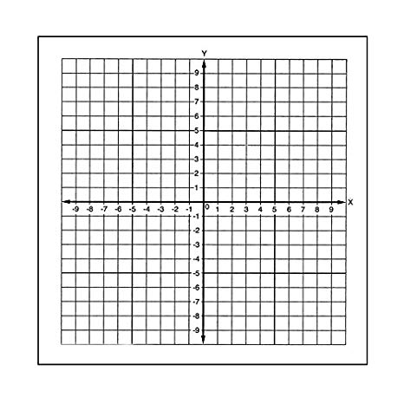

- Graph the following equations, Make 3 points for X and solve for Y
y = -2/3x - 1
- 2x + 3y = 6

- Graph the following equations, Make 3 points for X and solve for Y
y = 1/2x + 2/3

5) Find the X and Y intercepts then GRAPH the points
-5x + 4y = 20

- Find the X and Y intercepts then GRAPH the points

y = -2/3x + 4

7 and 8) Find the Slope of the two points m = y₂-y₁
X_{x}-x₁

(3,1) and (5,4)

(2, -3) and (5, 2)

9) Graph the line with the given slope and y intercept b remember y = mx+ b

m = ¾, and b = -3

10) m = 3, and b = -2

11) Find the slope and y intercept for each of the following equations and write them in y = mx+b then GRAPH THEM

2x - 5y = 10

12) -2x + y = 2

13-14) Find the equation that passes through the points below and write your answer in slope intercept form. Remember start with finding the slope , m = y₂-y₁
x₂-x₁

Then use the point slope equation y – y₁ = m(x₂ – x₁)

(2, 4) and ( -3, -1)

(-3, -5) and ( 3, 1)

15 -16) GRAPH THE FOLLOWING LINEAR INEQUALITIES

2x + y > 4

2x + 6y < 12

